Testing Lambda and Gateway API  
CS 470 Full Stack Development

Sergio Mateos

Southern New Hampshire University

Part One: Creating API Using API Gateway

1. 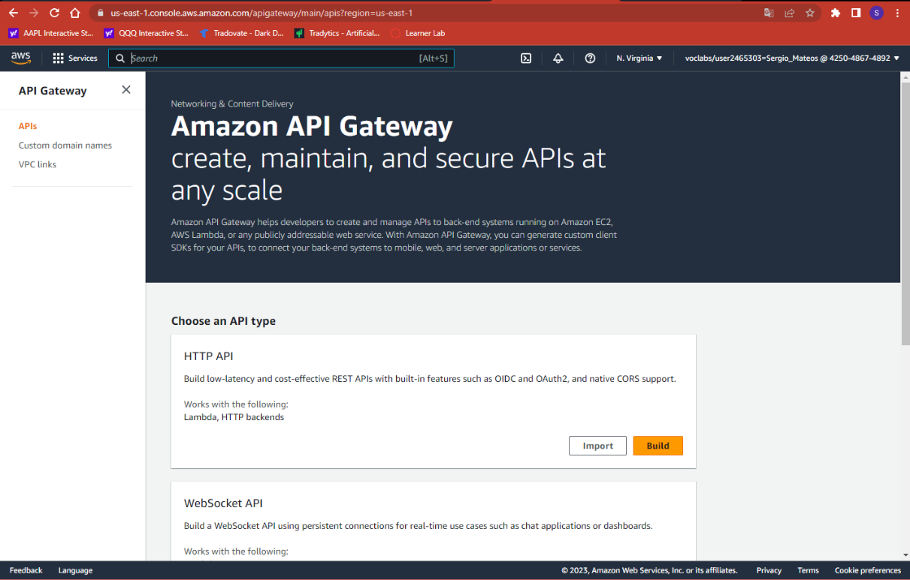API Gateway
2. 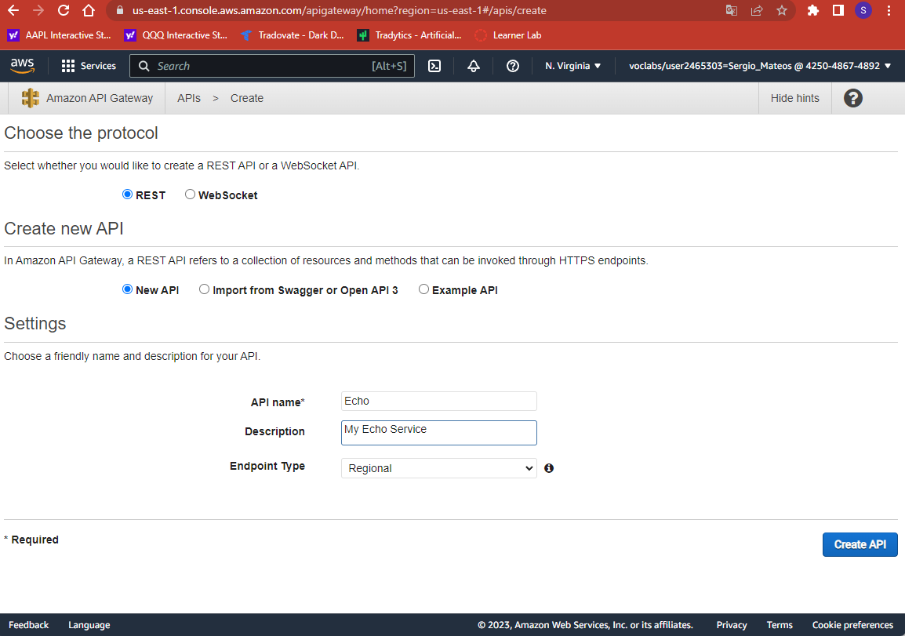Creating API

Part Two: Adding Method to your API.

1. 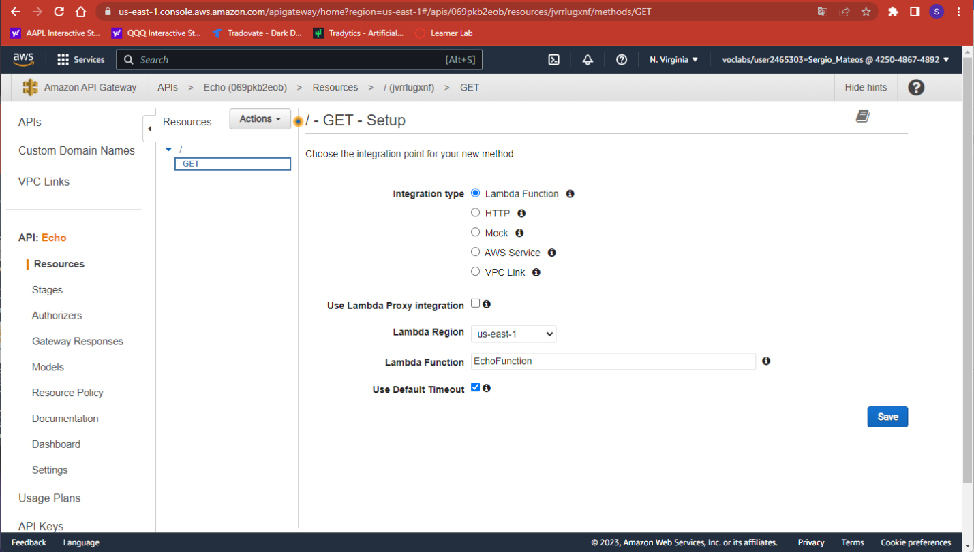Adding Method to the API
2. Graphical user interface

   Description automatically generatedGET Method Execution Page

Part Three: Testing your API to Lambda Method

1. 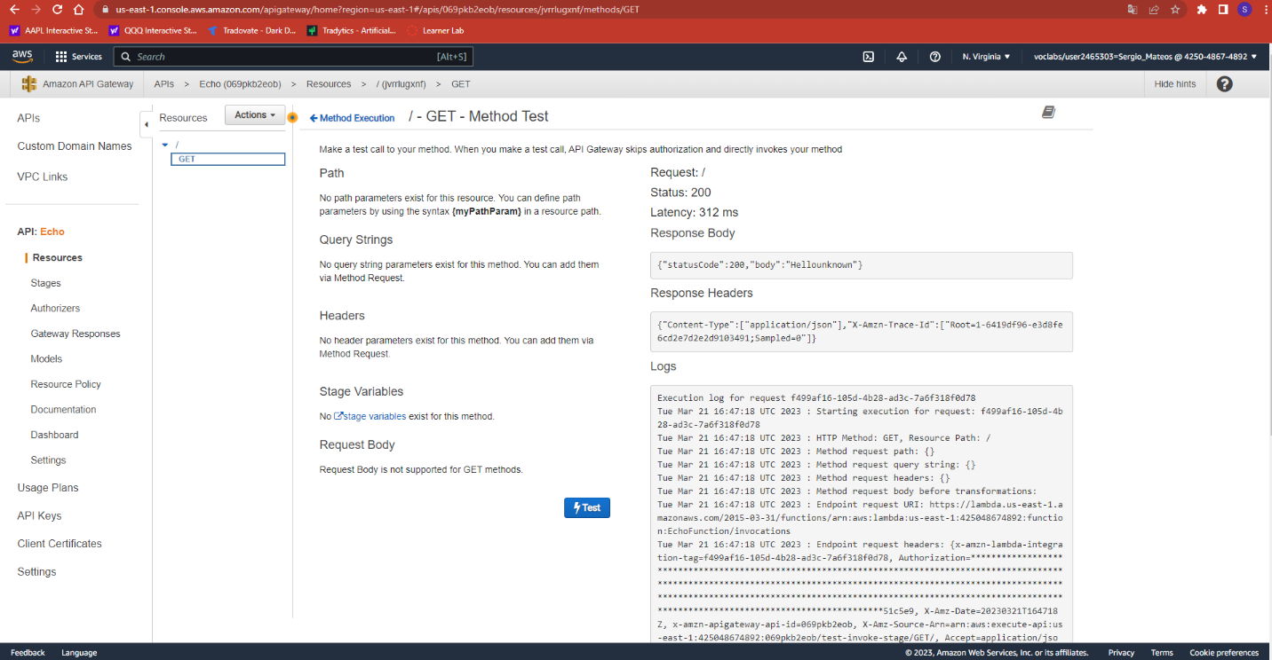Test
2. 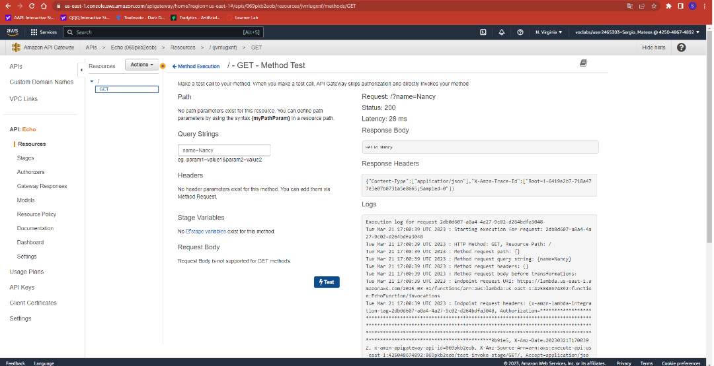GET Test Page

Part Four: Deployment your API

1. Graphical user interface, text

   Description automatically generatedDeployment
2. Graphical user interface, text, application

   Description automatically generatedURL Created
3. Graphical user interface

   Description automatically generatedTested
4. Personalized

https://069pkb2eob.execute-api.us-east-1.amazonaws.com/API?name=Sergio